According to wikipedia

“ In [statistics](https://en.wikipedia.org/wiki/Statistics), the **logistic model** (or **logit model**) is used to model the probability of a certain class or event existing such as pass/fail, win/lose, alive/dead or healthy/sick. This can be extended to model several classes of events such as determining whether an image contains a cat, dog, lion, etc. Each object being detected in the image would be assigned a probability between 0 and 1, with a sum of one.

Logistic regression is a [statistical model](https://en.wikipedia.org/wiki/Statistical_model) that in its basic form uses a [logistic function](https://en.wikipedia.org/wiki/Logistic_function) to model a [binary](https://en.wikipedia.org/wiki/Binary_variable) [dependent variable](https://en.wikipedia.org/wiki/Dependent_variable), although many more complex [extensions](https://en.wikipedia.org/wiki/Logistic_regression#Extensions) exist.”

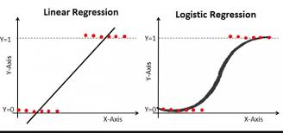

If class label is binary linear regression will not fit in the model since simply it is a straight line. But no worries there are plenty of functions in mathematics. Logit function graph can represent binary class labels.

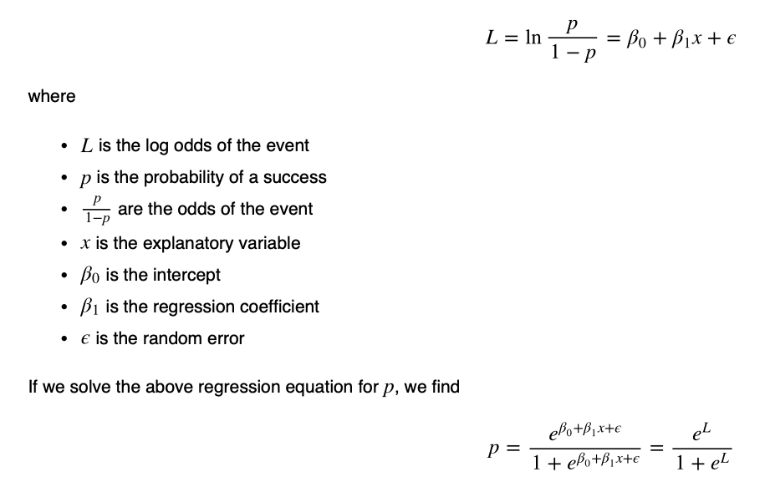

Then, our goal is to find β0 β1.

To identify β0 β1 we can use stochastic gradient descent. Instead of Mean Squared Error, we use a cost function called Cross-Entropy, also known as Log Loss.

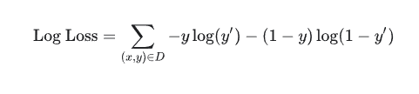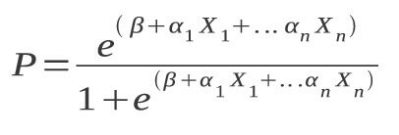

If there are more than one explanatory variable then it will multiple logistic regression. And we need to identify y-intercept and each a value by using stochastic gradient descent.

Python Sklearn Implementation

Import libraries

Load data

Clean data

Separate futures and target

(Split data into train and test for some cases to find accuracy, Also we may need to normalize input for some ML algorithm)

Define the model

Fit the Model

Predict

